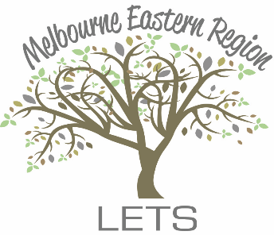
MERLETS
Melbourne Eastern Region LETS Inc.
39A Royal Ave
Heathmont 3135 VIC
Tel. 0424 008 482
merletsinc@gmail.com
www.merlets.org.au

INVOICE
Membership Renewal 2023/24

Date Due: 1st July 2023

Renewal fee: $10 per year

Please note, there is an Annual Administration fee of 25 tokens, plus a 5% levy on all transactions.
Payment: You can make payment in the following ways:

Direct deposit or internet banking to:
Bank: Bendigo Bank
Account Name: Melbourne Eastern Region LETS Inc.
BSB: 633 000
Account No.: 123 696 213
Reference: Your surname and ‘Subs’

Cheque: make payable to Melbourne Eastern Region LETS Inc.
and post to 39A Royal Ave, Heathmont:

Cash - please give directly to Ann Heskett, Treasurer/Secretary

If there are any changes to your details
please notify MERLETS via email/mail,
and update the CES site (www.communityexchange.net.au)

Building Community Sharing Skills

